**Aim: To study and implement website hosting in cloud**

**Theory:**

1. **Introduction of Project Topic**

Cloud webhosting is hosting that uses the resources of several clustered servers. Basically, this means that your website uses the virtual resources of several servers to accommodate all the aspects of hosting your site. The load is balanced, security is taken care of and hardware resources are available virtually so they can be used when needed. The cluster of servers is the cloud.

Cloud hosting is often a solution for web sites that have outgrown the resources of their existing shared hosting provider. If a web site is extremely popular and causes a strain on the resources supplied by a shared server, you may need to find another solution. Often this solution is dedicated hosting where your site resides on its own server. The problem with dedicated hosting, though, is that it is both significantly more expensive and requires a certain level of IT know-how. With cloud hosting, you can have many of the advantages to dedicated hosting without most of the challenges.

Amazon Web Services offers cloud web hosting solutions that provide businesses, non-profits, and governmental organizations with low-cost ways to deliver their websites and web applications.

We use the ‘Static website hosting’ feature of the S3 bucket; the ‘ec2’ instance and a combination of ‘Route53’, ‘CloudFront’, ‘Certificate manager’ and the S3 bucket to host our demo website in 3 different ways.

1. **Background Knowledge**

I achieved the [AWS Certified Cloud Practitioner (CLF-C01)](https://www.credly.com/earner/earned/badge/35687239-c7fb-4d31-abec-39e0f10252f5) on July, 2020 and I found AWS to be the most fascinating because of its wide range of service offerings and a very user-friendly web console. Exploring AWS and learning about its services via online learning platforms, books, etc. helped in making this project functional.

1. **Block diagram**

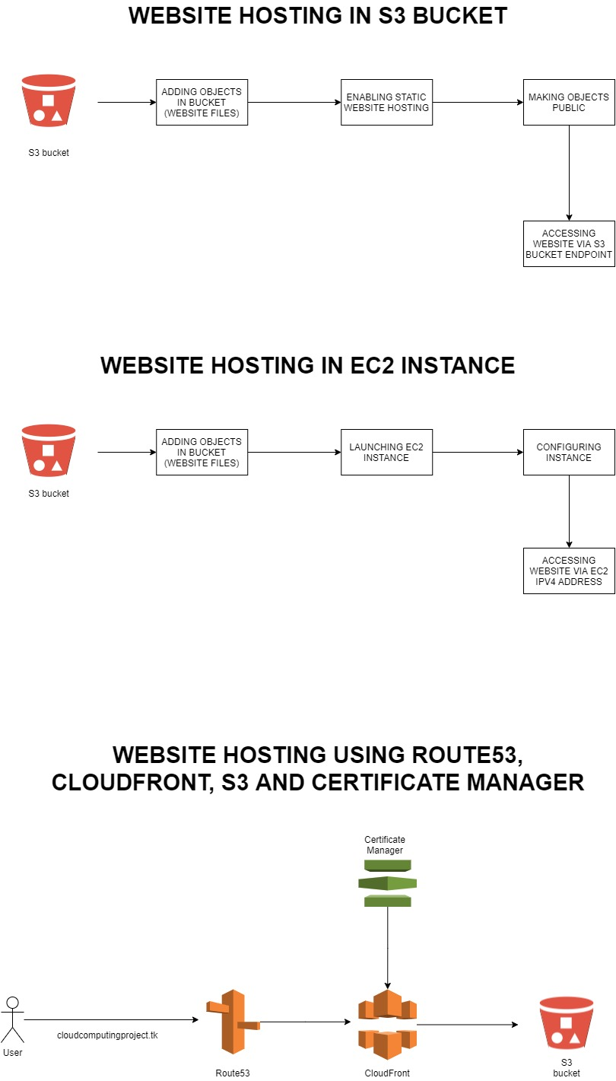

1. **Implementation (Screenshot Included):**

**The demo website created using HTML, stored in local:**

Index.html:

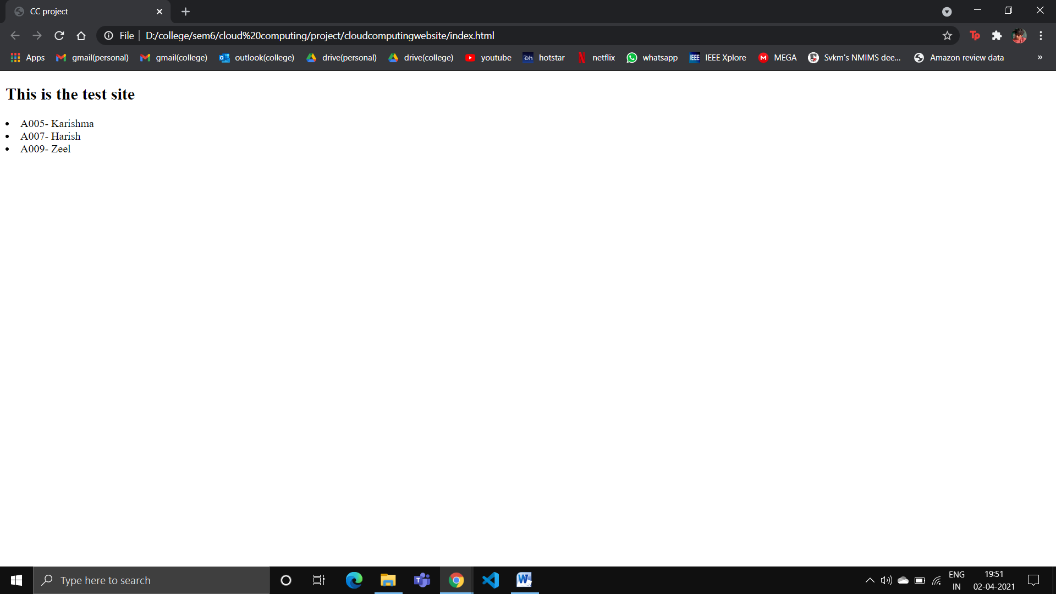

Error.html:

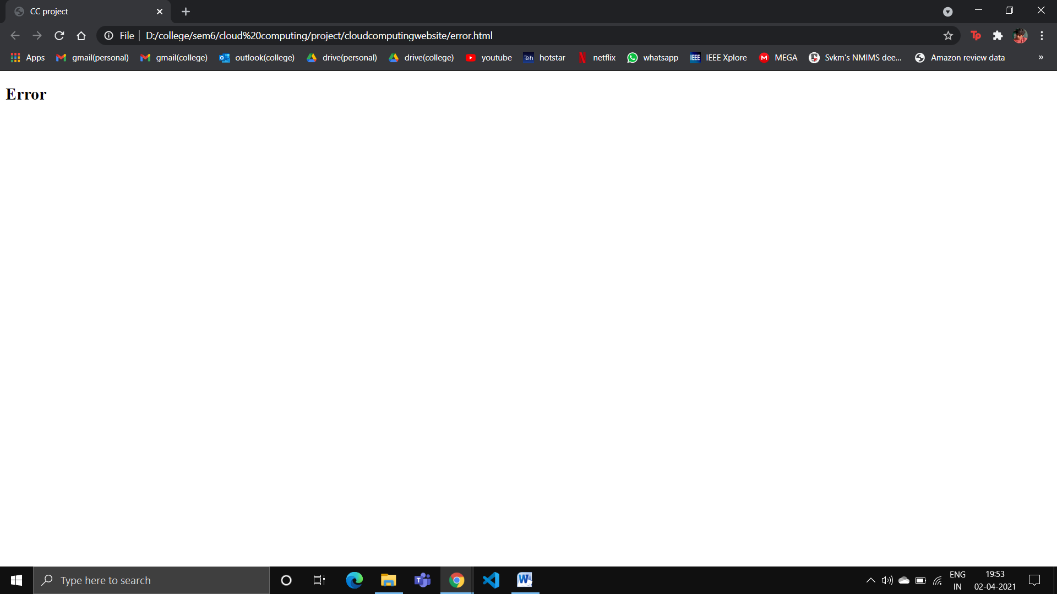

**The demo website hosted in S3 in AWS:**

The S3 bucket named ‘cloudcomputingwebsite’; the website files are added:

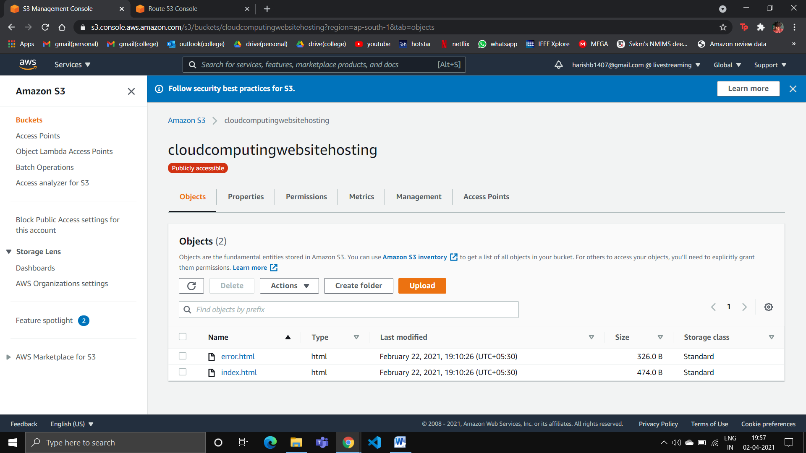

Enabling static website hosting in bucket; the url below is the website endpoint:

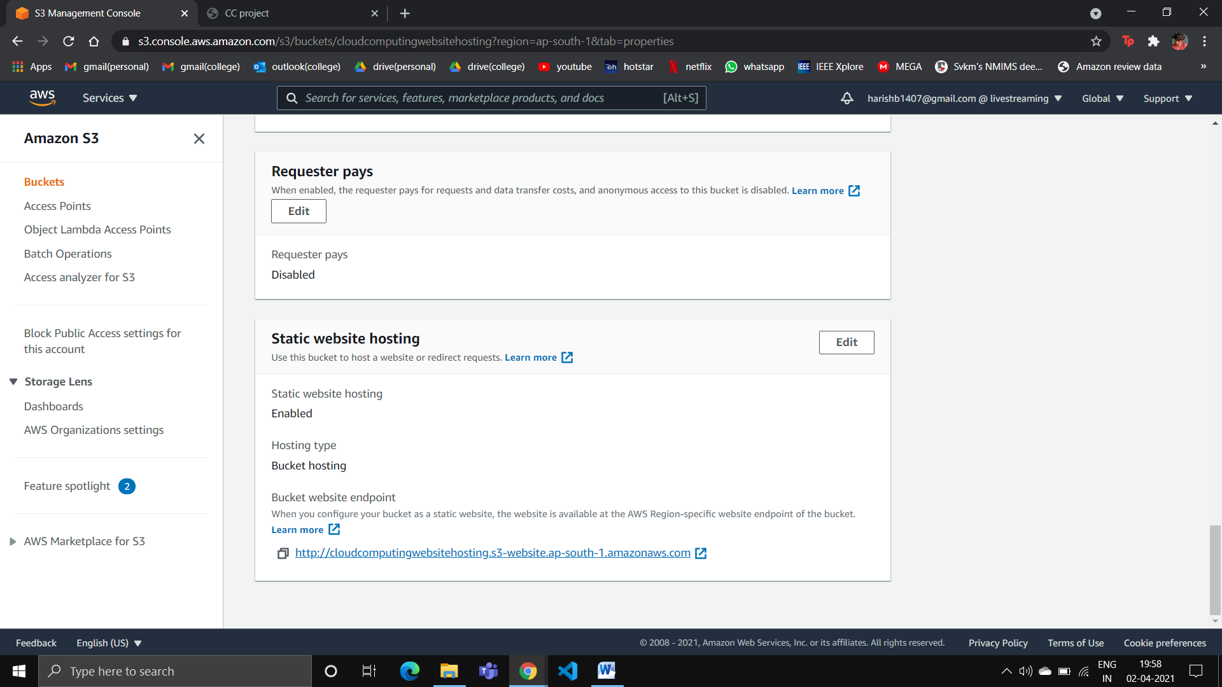

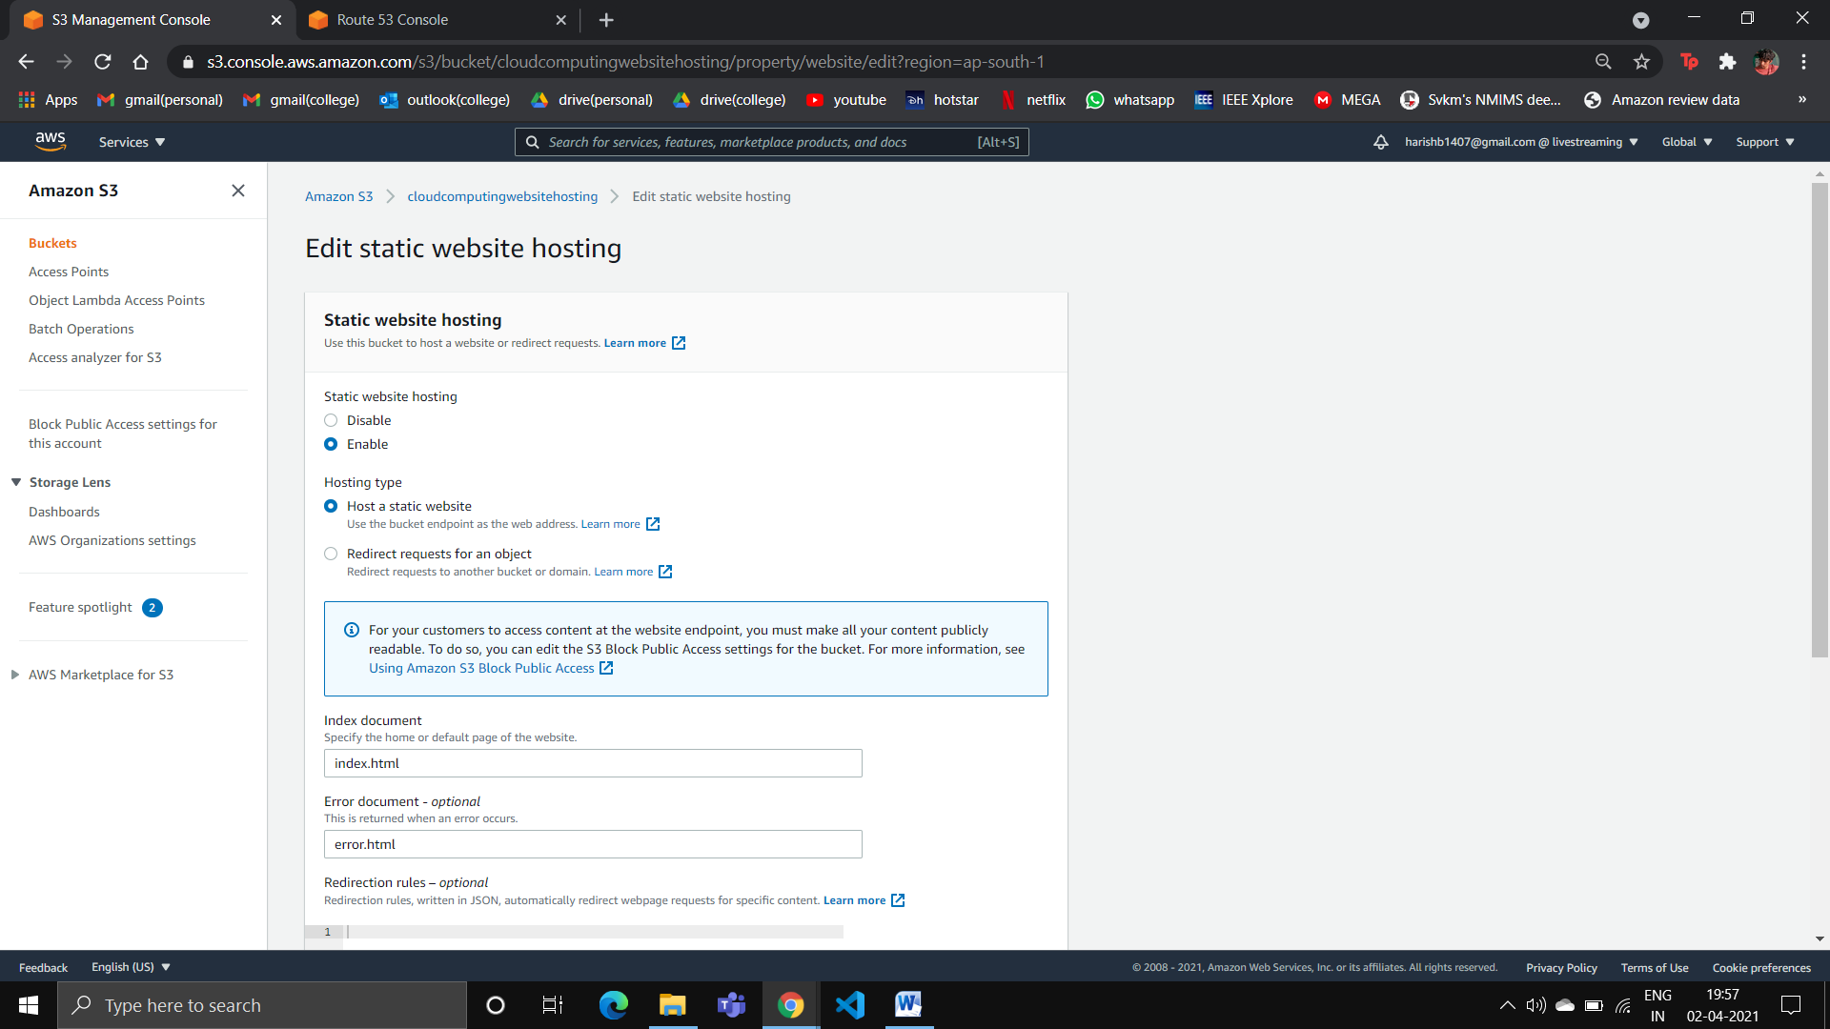

Clicking the url opens up the website (<http://cloudcomputingwebsitehosting.s3-website.ap-south-1.amazonaws.com/>):

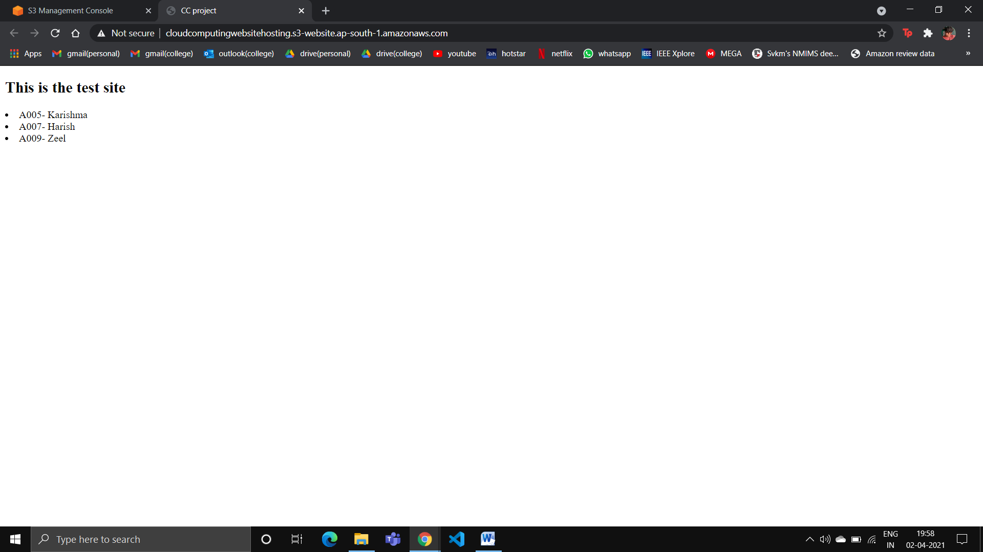

Entering the wrong url:

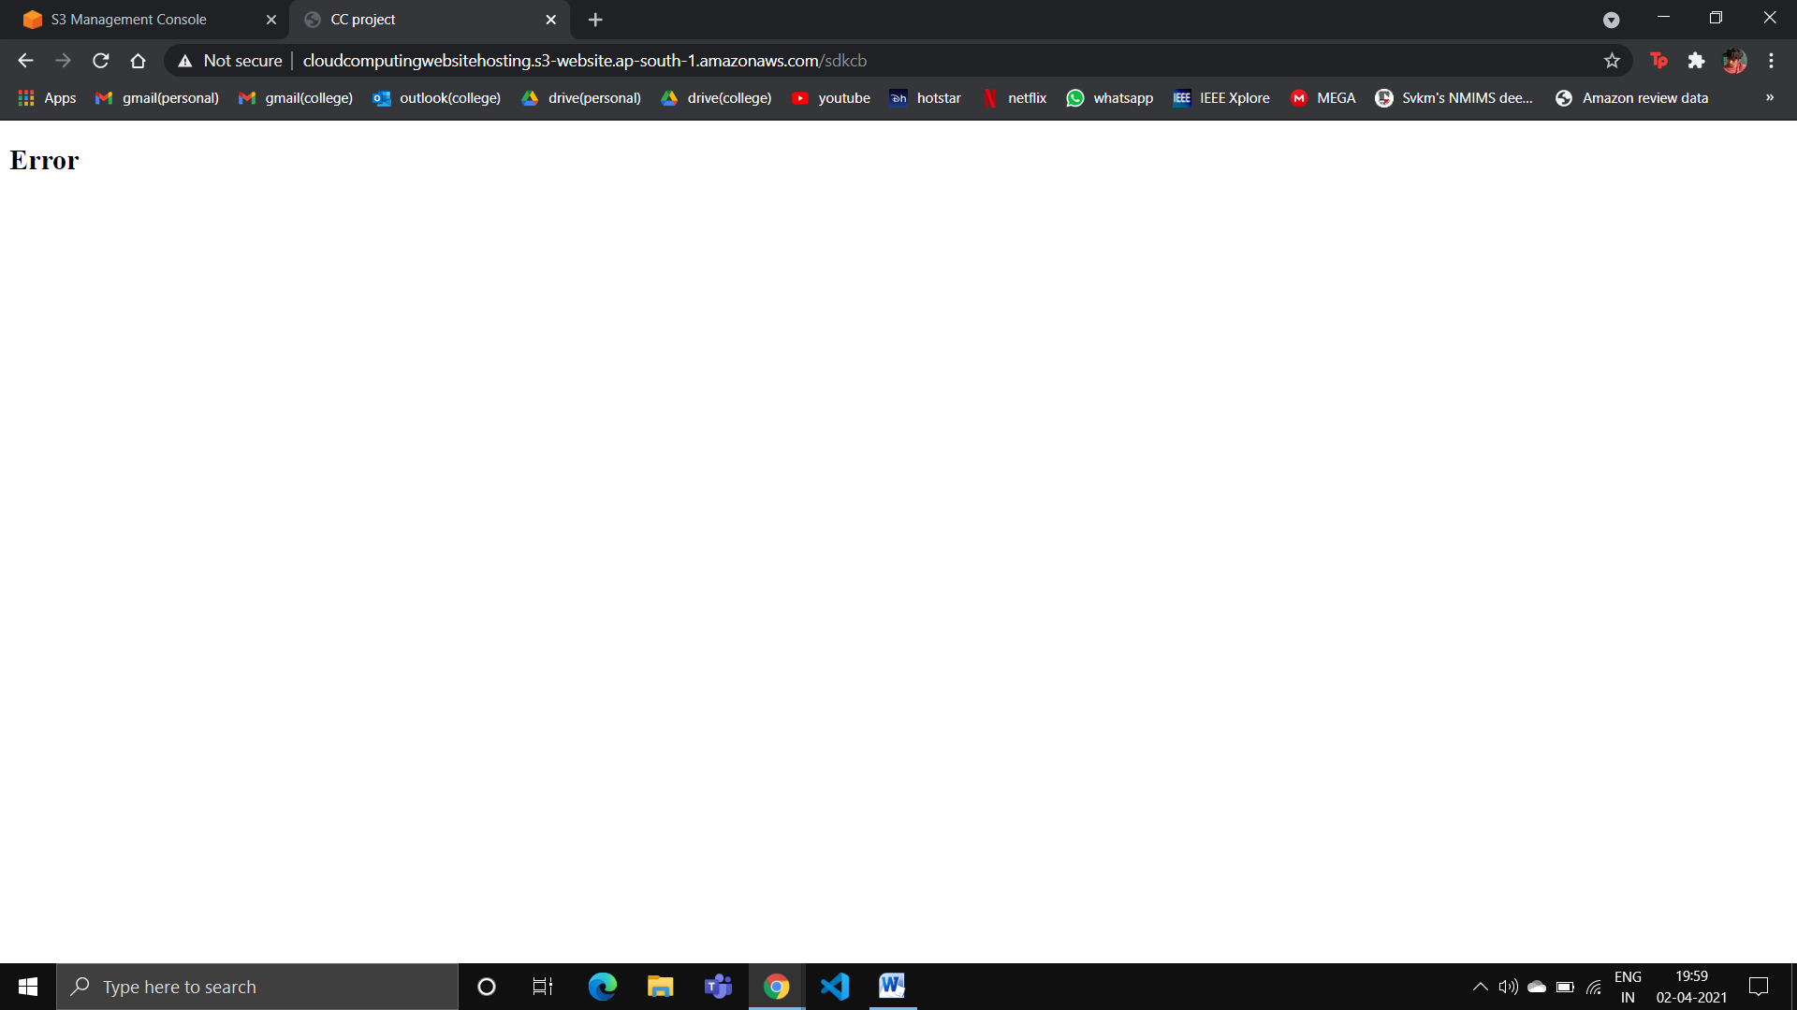

**The demo website hosted in an ec2 instance in AWS:**

Website zip file is added in an S3 bucket named ‘cloudcomputingwebsitehostingec2’:

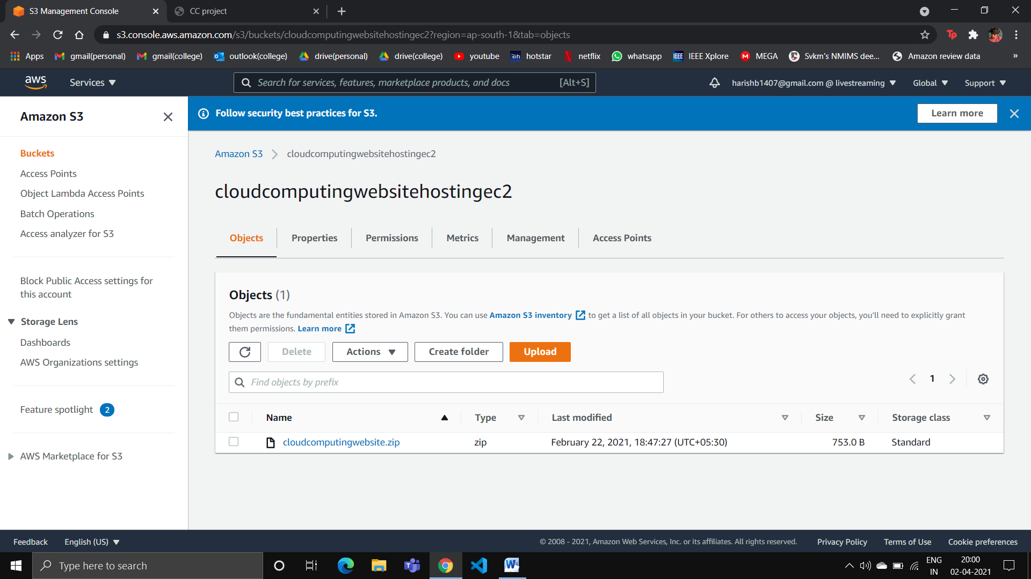

EC2 dashboard:

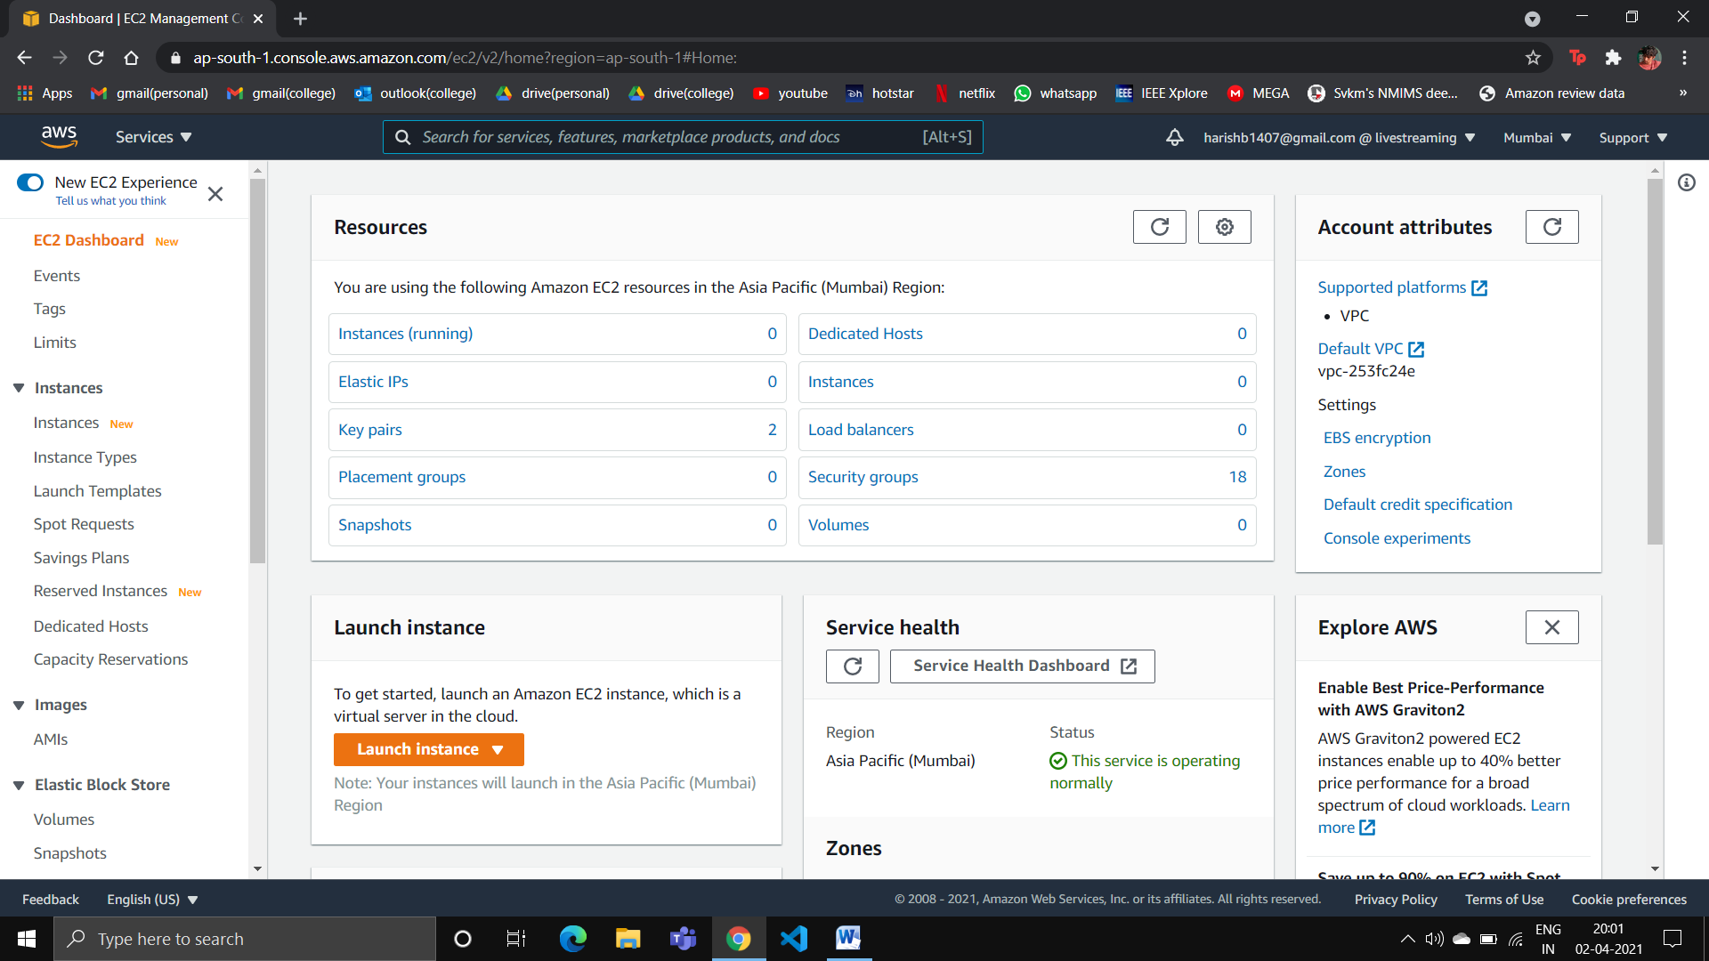

Launching an ec2 linux instance:

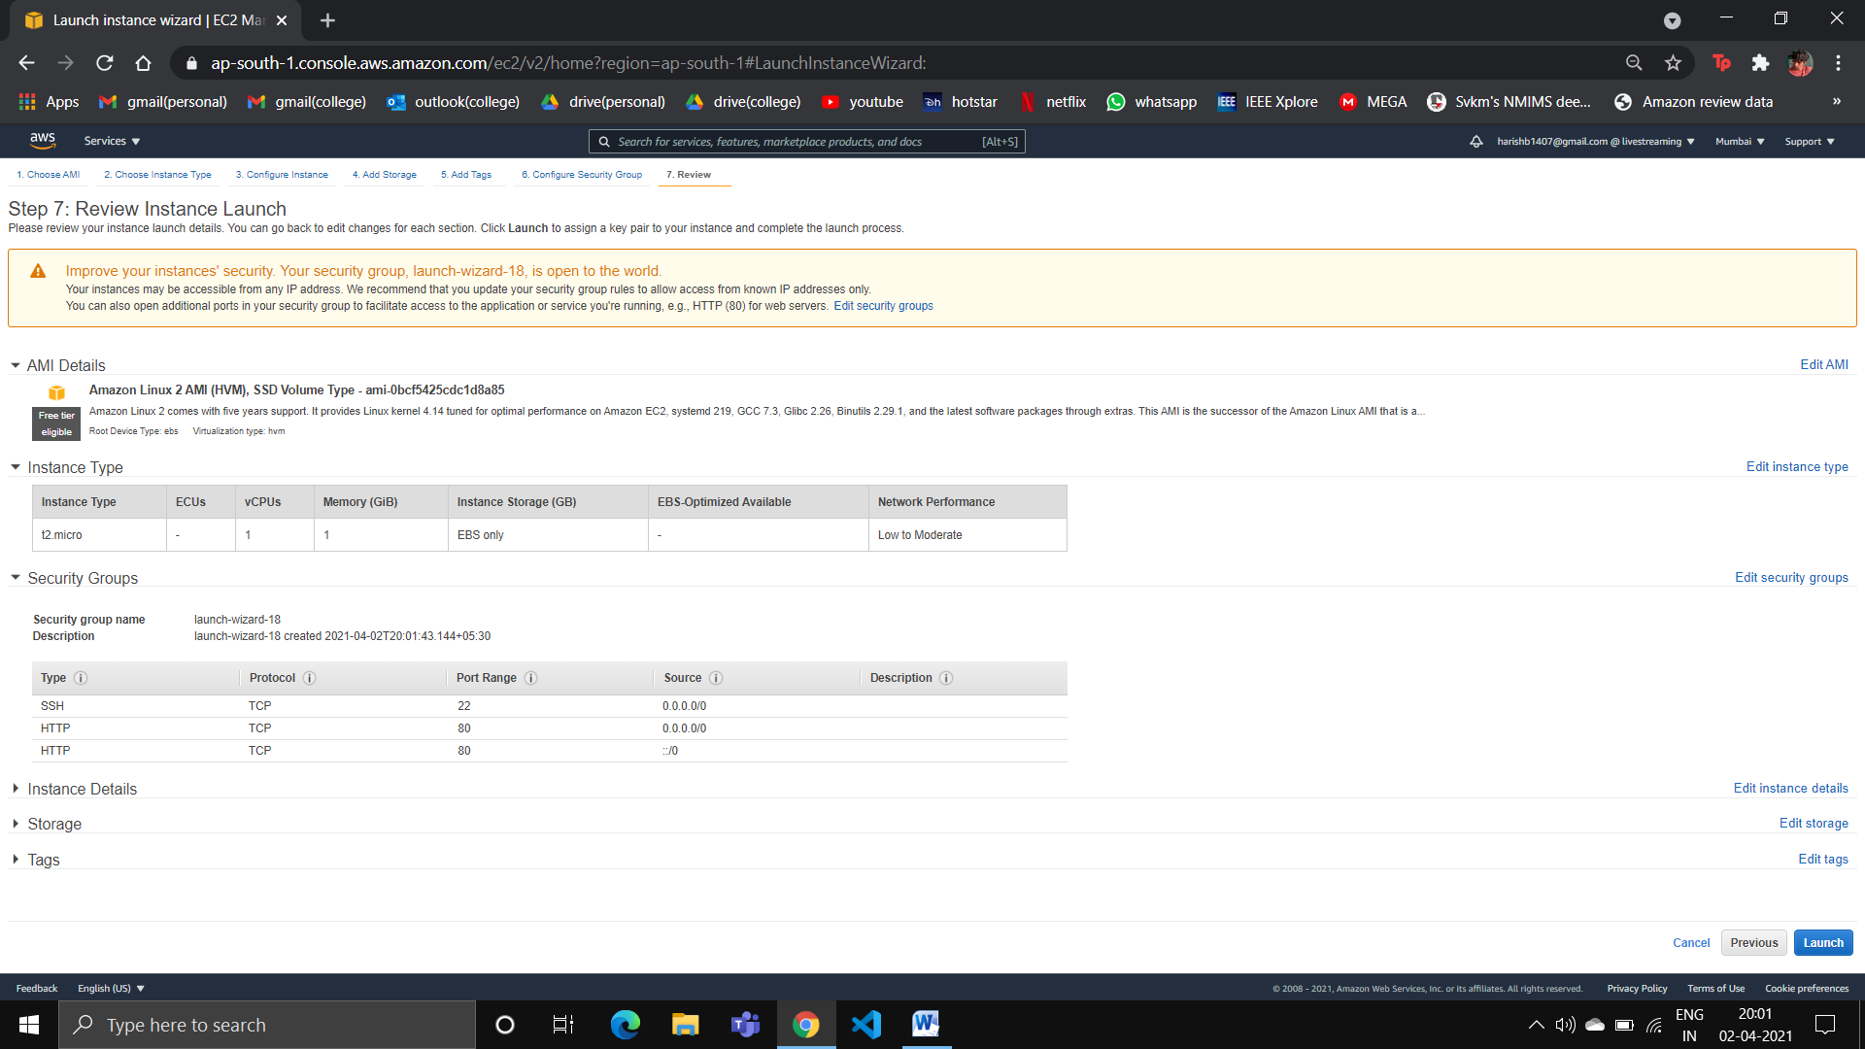

The instance details including the IPv4 address which will be website endpoint:

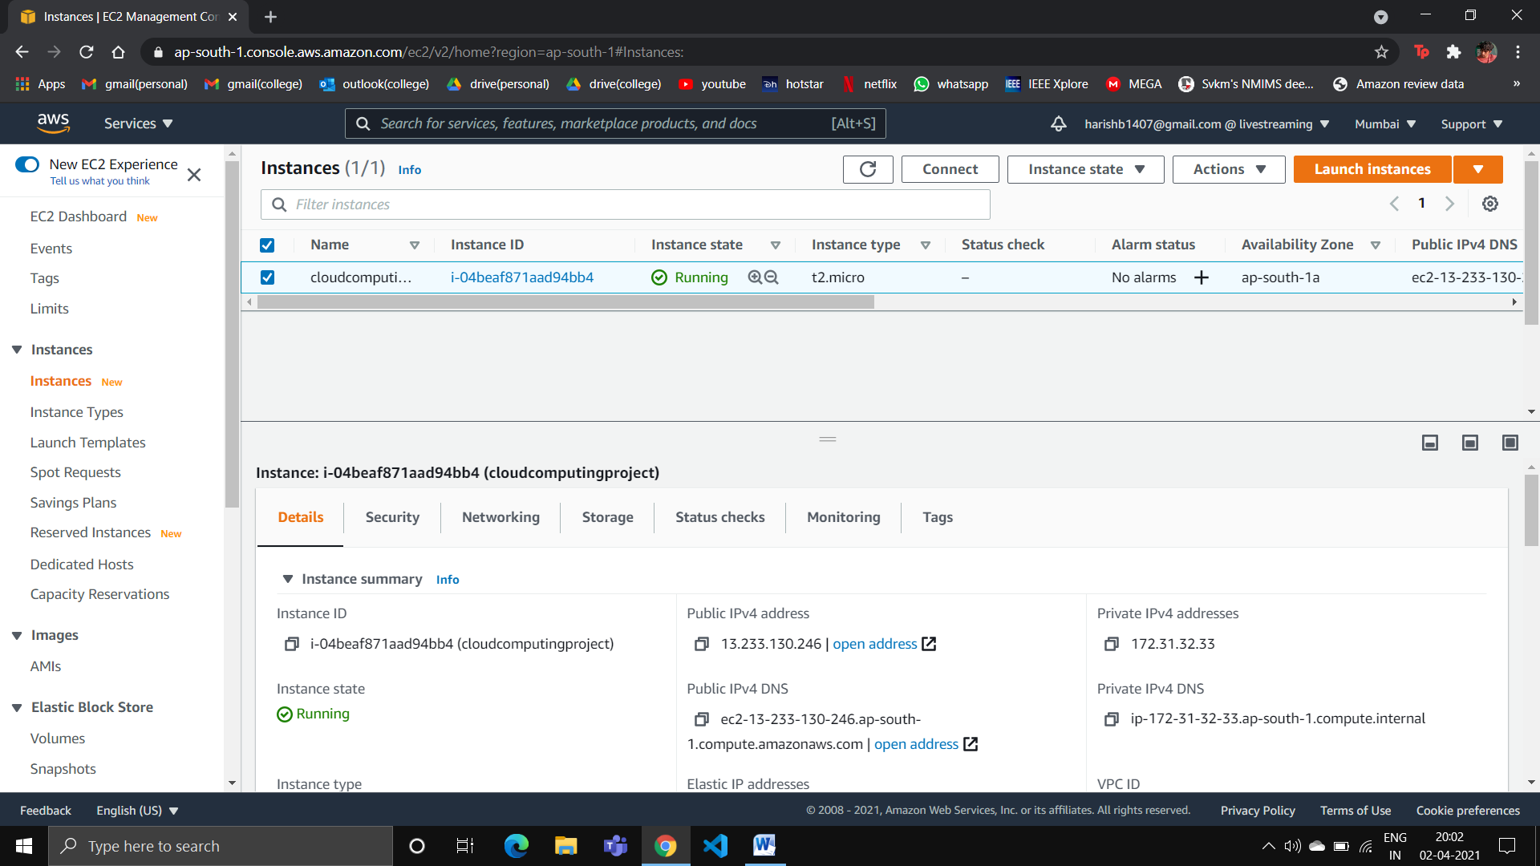

Using putty to SSH into the ec2 linux instance:

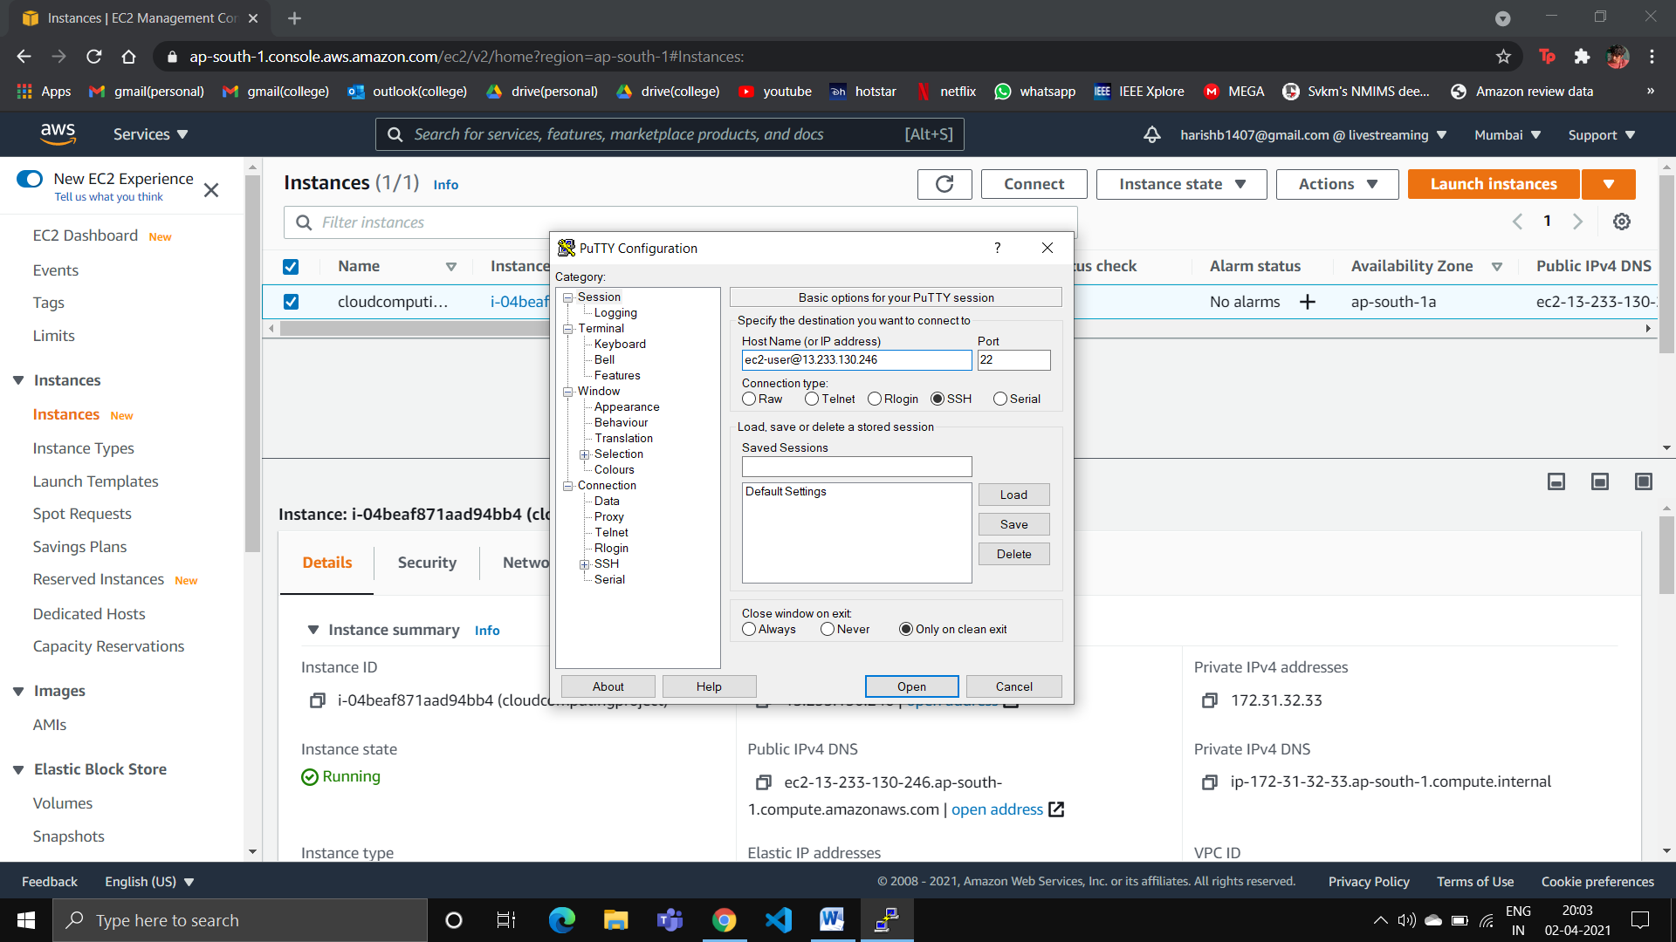

The ec2 linux instance:

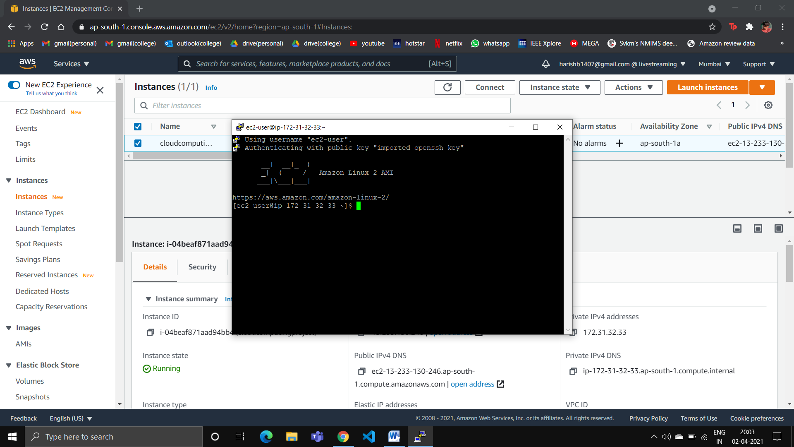

Entering the following commands in the ec2 linux instance:

- sudo su

- yum update -y

- yum install httpd -y

- cd /var/www/html

- wget <https://cloudcomputingwebsitehostingec2.s3.ap-south--> 1.amazonaws.com/cloudcomputingwebsite.zip

- unzip cloudcomputingwebsite.zip

- mv cloudcomputingwebsite/* .

- service httpd start

Pasting the IPv4 address in browser shows us the website:

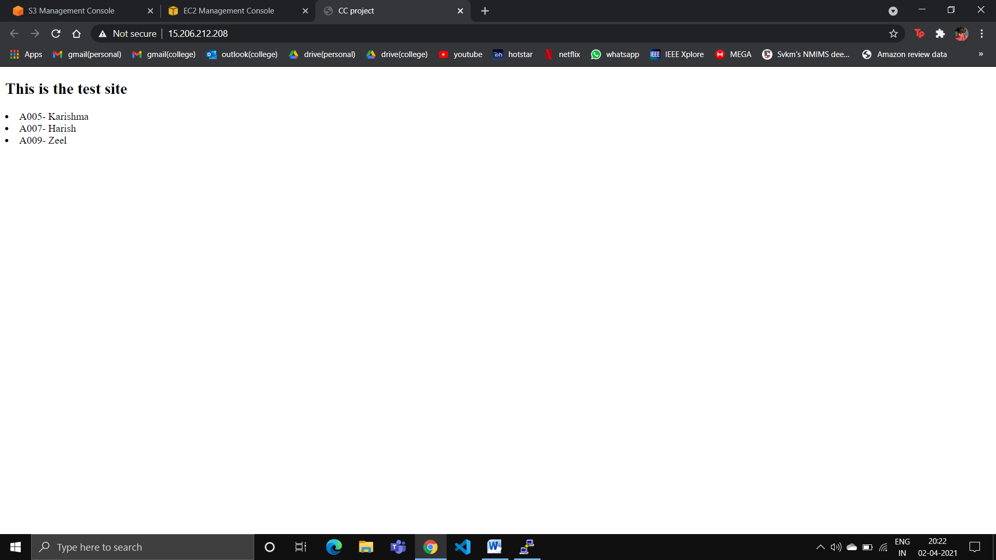

**Accessing the website using a unique domain name:**

Purchased domain name ‘cloudcomputingproject.tk’ in freenom.com:

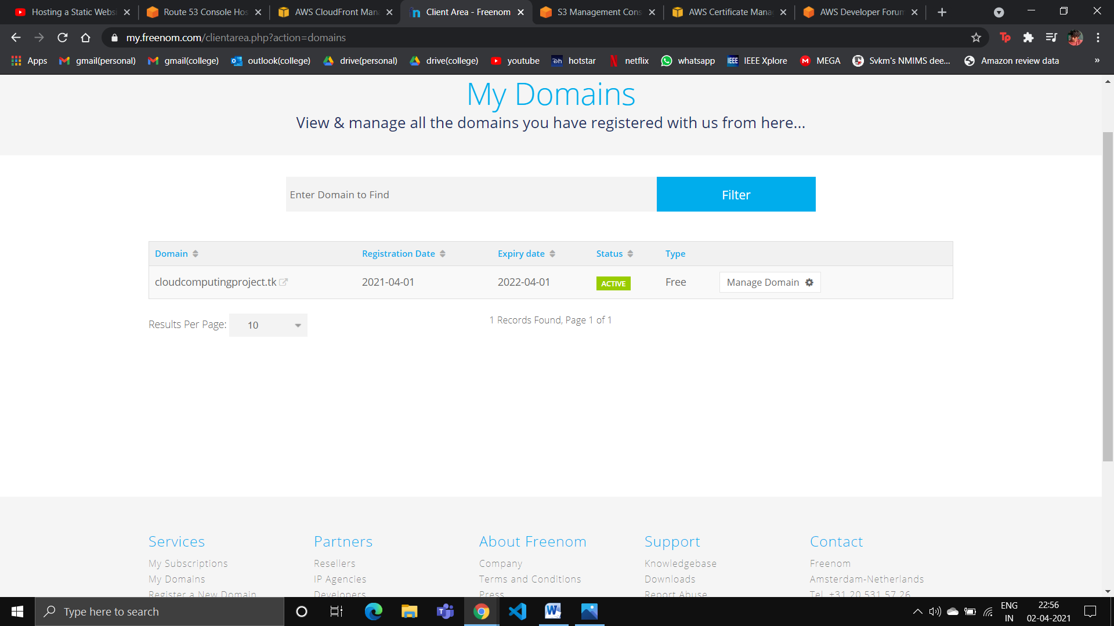

Certificate created in Certificate Manager:

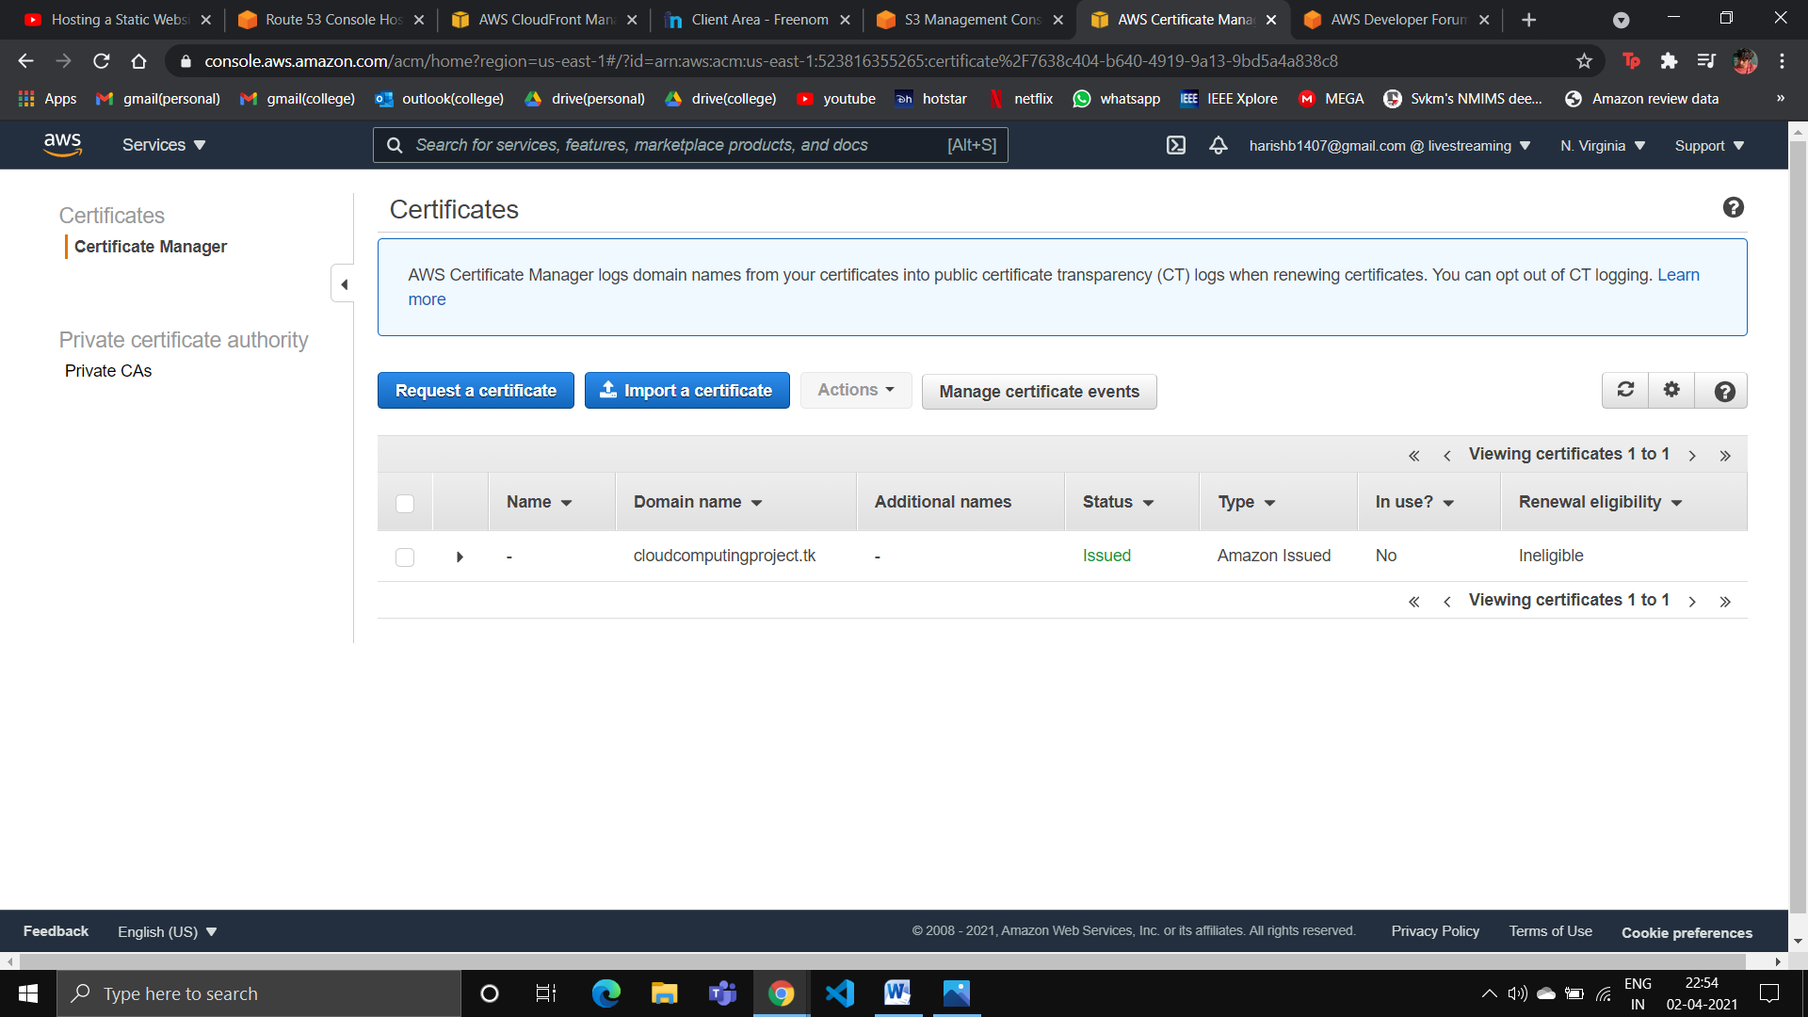

Bucket in S3:

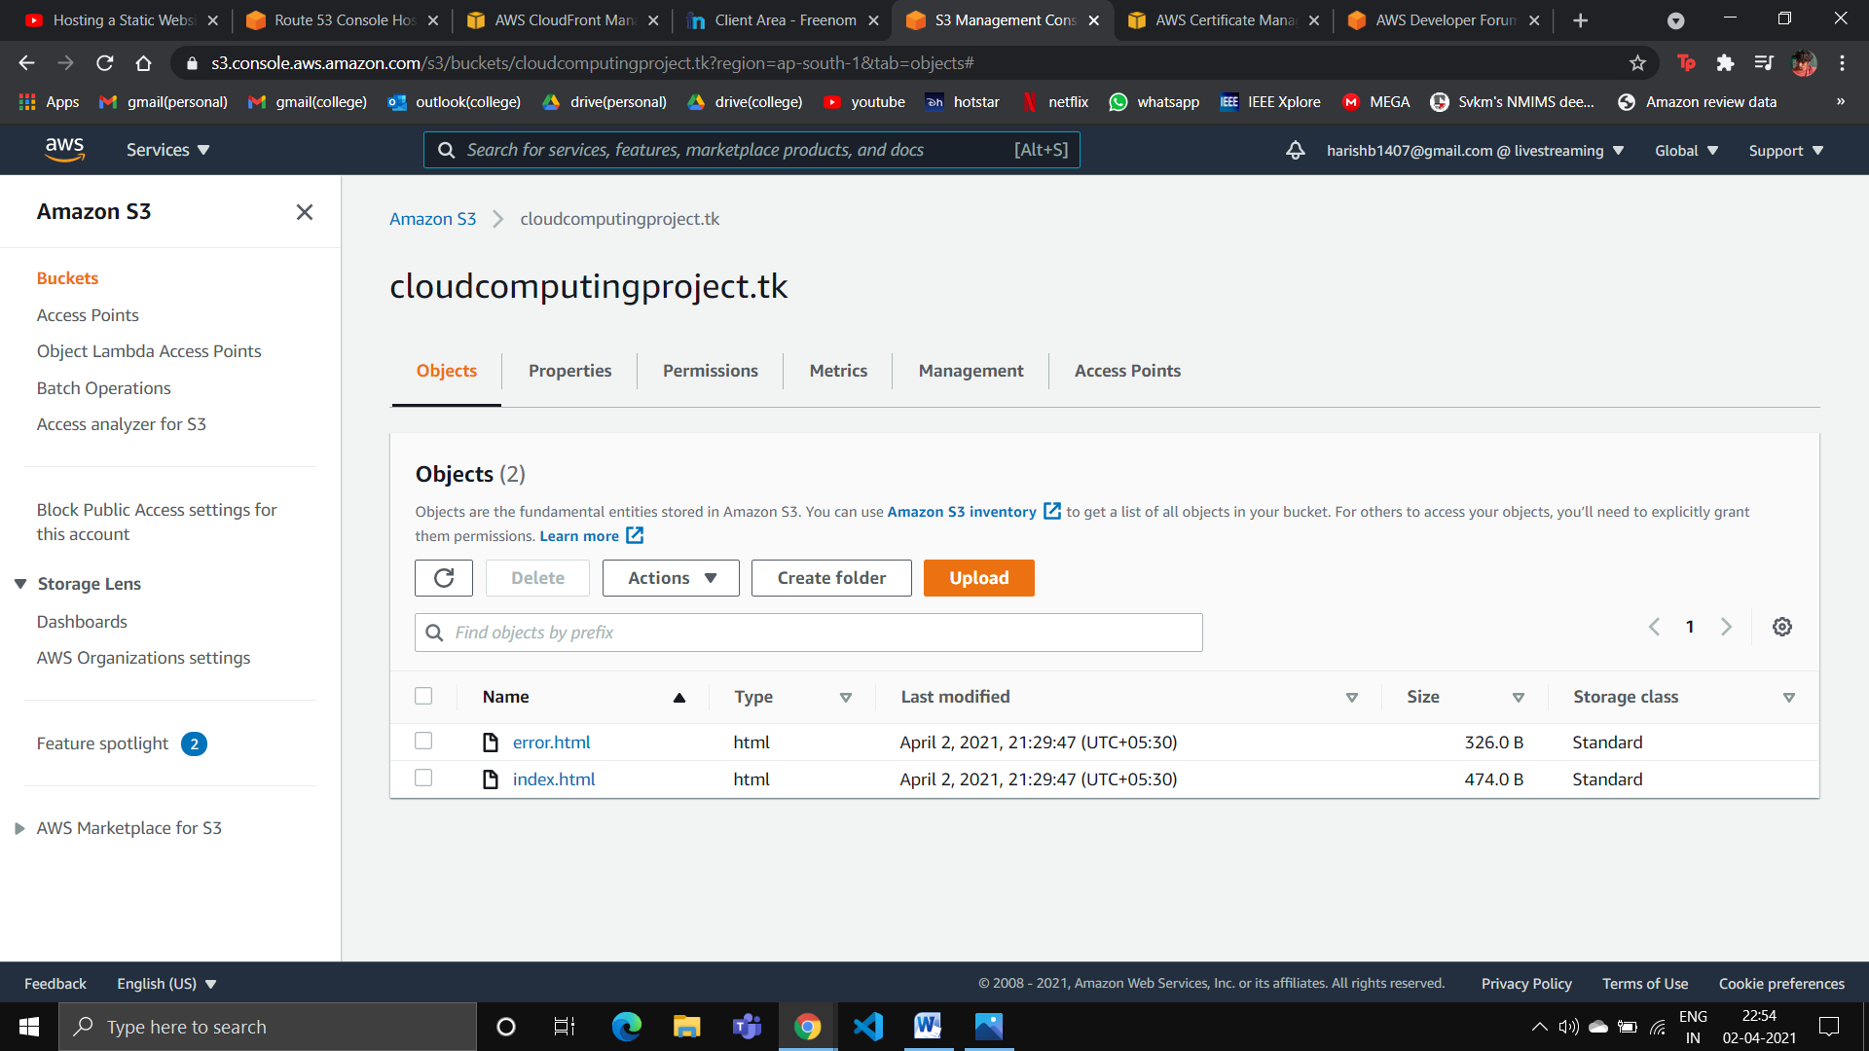

Distribution created in CloudFront:

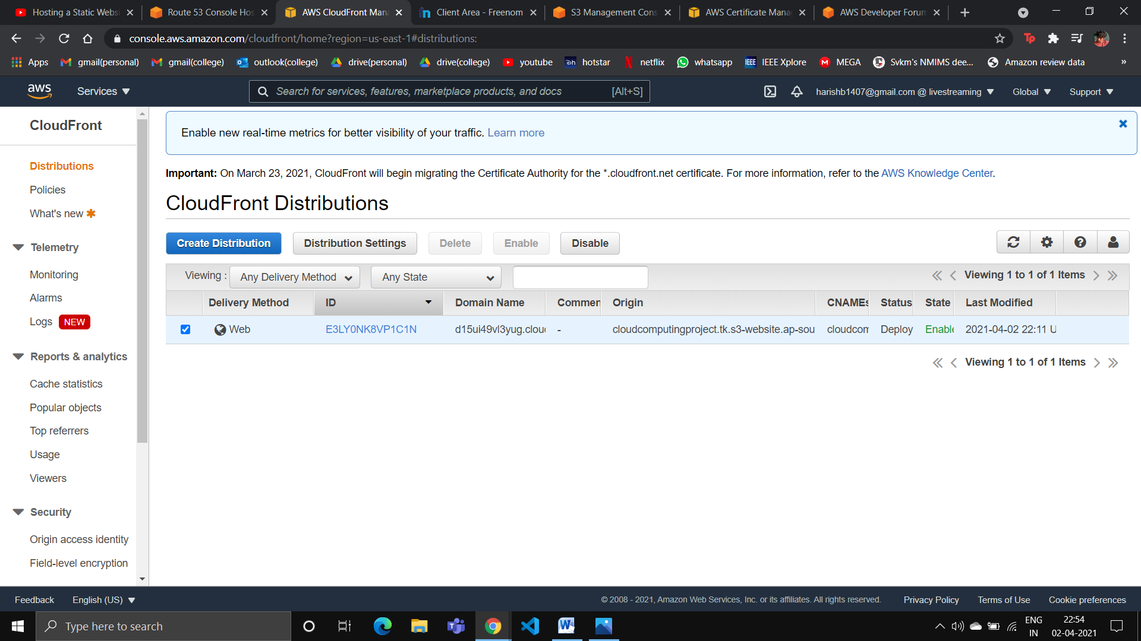

Hosted zone created in Route53: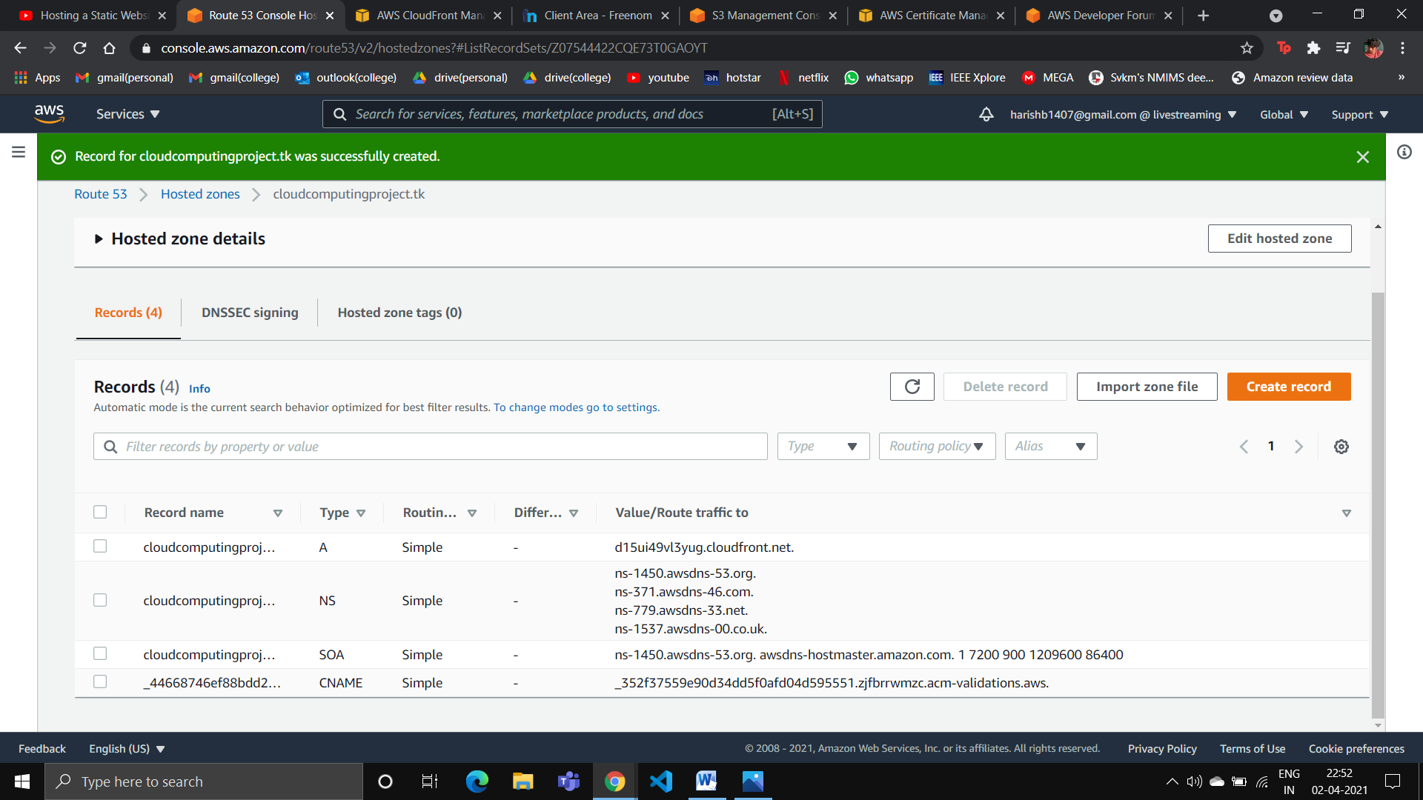

Typing ‘cloudcomputingproject.tk’ in the browser:

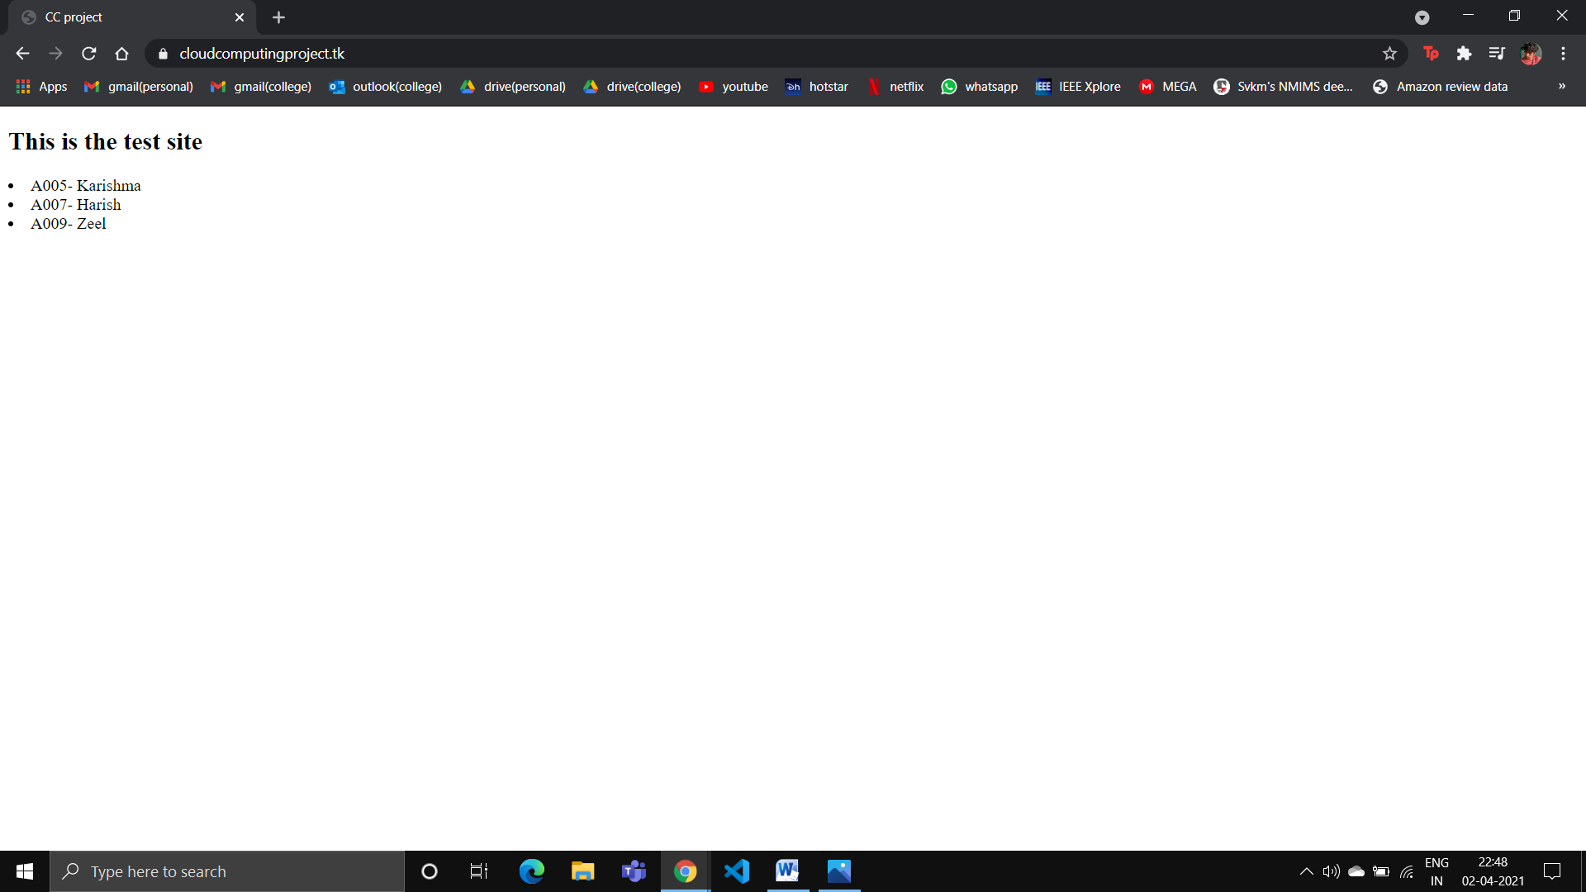

Typing something wrong in the browser:

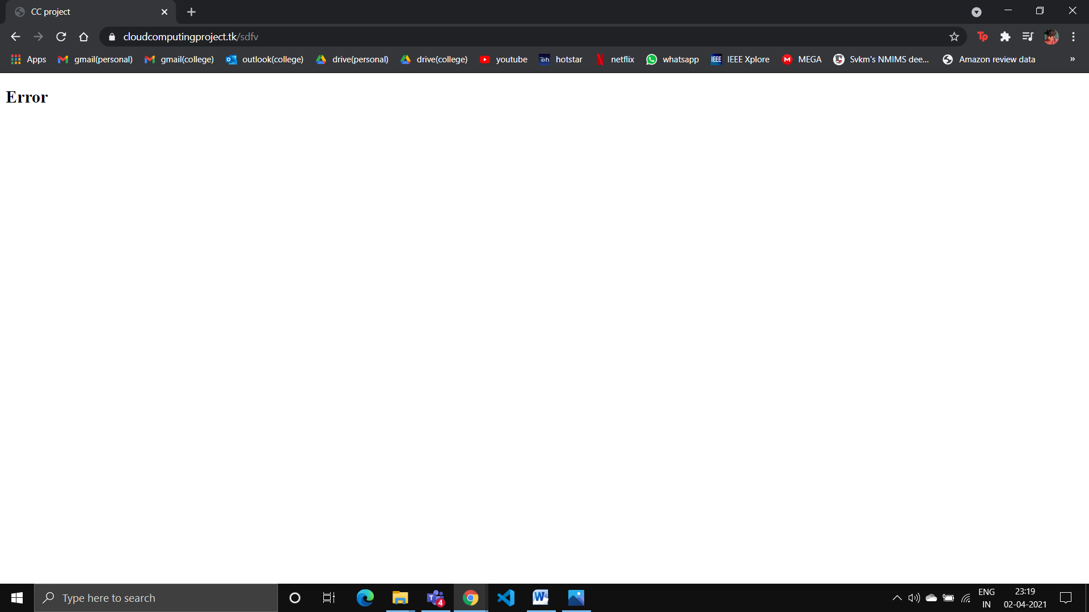

**Advantages & Limitation of project:**

Advantages:

* Website can be accessed from anywhere in the world using ‘cloudcomputingproject.tk’ domain name.
* The website will be cached in different edge locations around the world because of the ‘CloudFront’ distribution, which will make accessing the website a much faster process.
* The website hosting is almost cost free as the charges are applied only for the hosted zones created via Route53 and the CloudFront distribution.

Limitations:

* We cannot keep the website running forever because that would mean spending money on hosting it which is out of the scope of this project.
* The website hosted in ec2 instance can only be accessible by the IPv4 address, which will not be available to everybody.
* The website hosted in S3 can prove to be a disaster because the ‘public access settings’ can be easily changed and anybody can misuse the website.

**Conclusion:**

The website was successfully hosted in S3 bucket, ec2 linux instance. A domain was purchased, and by using Route53, CloudFront, S3 and Certificate Manager, the domain was linked with our website for global distribution.